**Assignment #3. Advanced CSS ( Flexbox & Grid)**

**Student**: Urazbekova Amina

**Group**: MT-2406

**Part 1. Flexbox**

In the first part, I created a header section with my logo on the left and a list of links to the other pages on the right. I turned it into a flex container and aligned the logo and the links horizontally. Then, I created a container with three cards using Flexbox. Each card there have a title, short text, and a button. The cards were styled with shadows and hover effects to make them interactive.

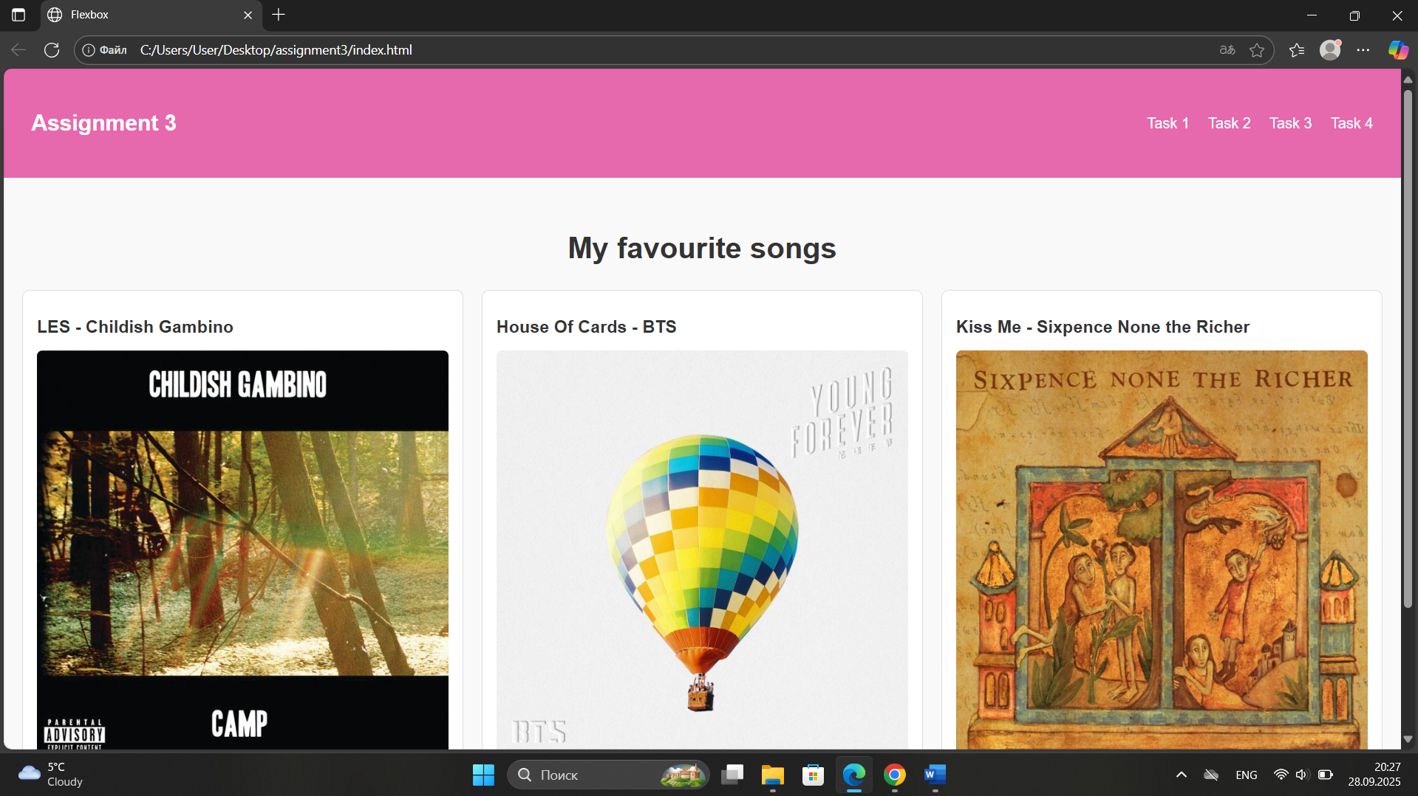

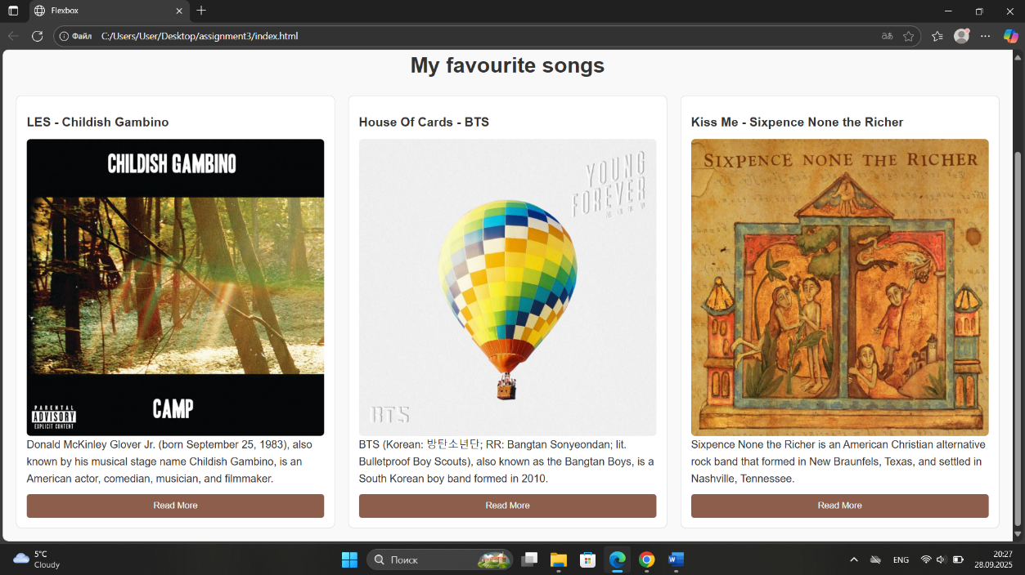

**Part 2. Grid System**

**Task 2. Page Layout with Grid Areas**

Here I set up a layout for a personal blog page by using CSS Grid. The page included a header at the top, a sidebar on the left with categories, a main content area with a welcome post, and a footer at the bottom. The grid layout helped to divide the page into clear sections and to give it a more professional look.

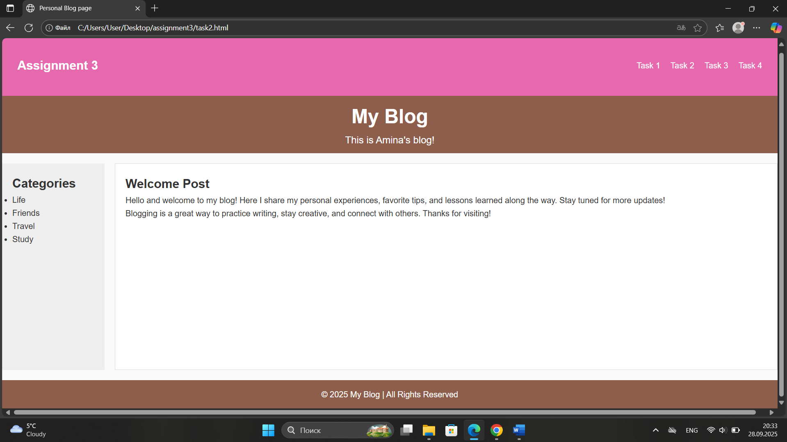

**Task 3. Image Gallery**

In this task, I needed to create a gallery page with several photos in it also using CSS Grid. First, I collected nine different images of flowers and placed them inside a gallery container. The gallery shows the images in three column grid with the names as their captions. Each photo has a hover effect, and a caption that fade in at the bottom.

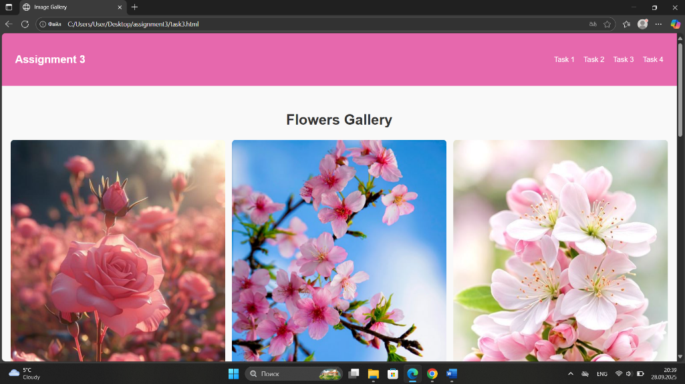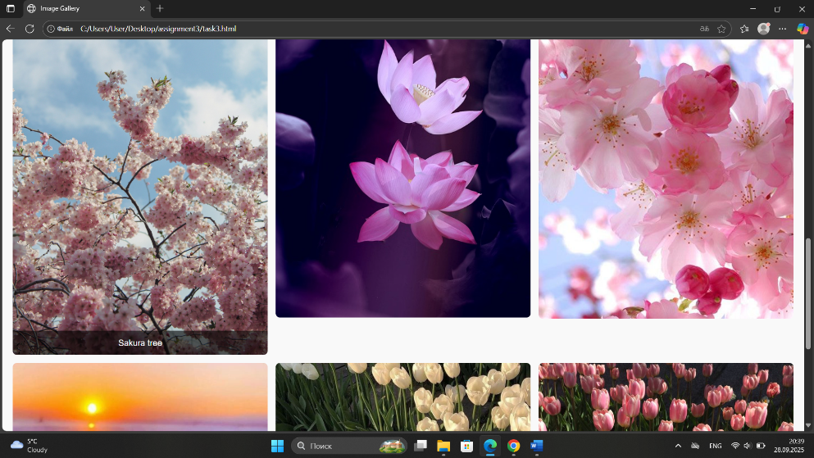

**Part 3. Combining Flexbox & Grid**

**Task 4. Portfolio Page**

In the last task, I created a portfolio page that combined both Flexbox and Grid. As I did in the second task, here I added a header, main section, sidebar, footer and the navigation bar at the top, that also was in every page before this. For the main content I used Grid to organize two sections which are, an assignment area on the left, and a sidebar with personal information on the right. I styled the assignment cards with Flexbox to arrange text and buttons, then a footer that was added at the bottom to complete the page layout.

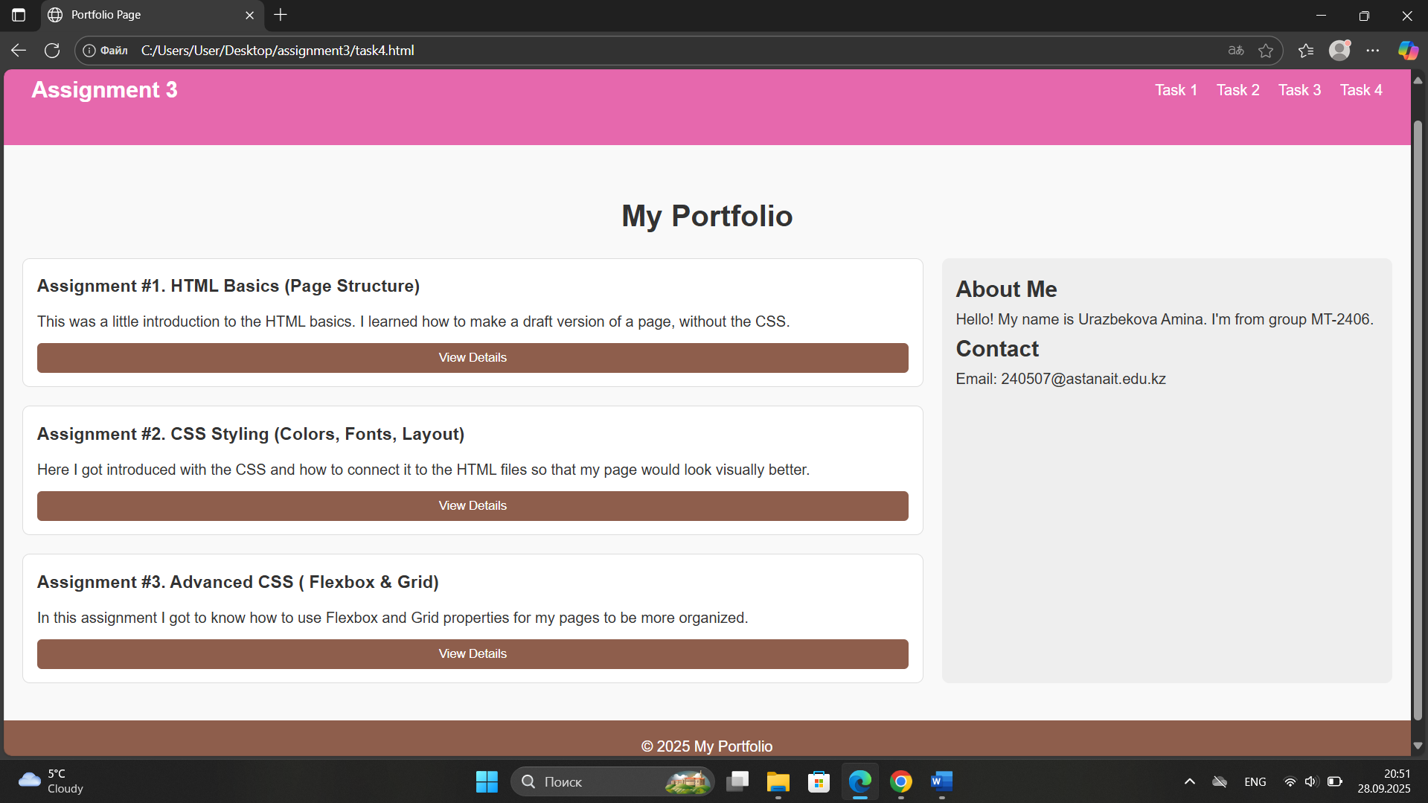

**Summary**

Throughout this assignment, I practiced using both Flexbox and Grid to build different types of layouts. Task 1 helped me to understand how Flexbox divides space and organizes items. Task 2 showed how I can create page layouts like blogs, by using only CSS Grid. Task 3 combined Grid with hover effects and positioning to create a gallery. Task 4 asked to use both techniques to design a complete portfolio page with multiple different sections.

This project improved my ability to work with advanced CSS layout techniques and gave me a clear understanding of when to use Flexbox and when to use Grid. It also helped me gain experience in styling elements and thinking about responsive design.